Vanessa Bridges
SOL Lab 5: Integumentary system
Learning Objectives:
- Identify the tissue and cellular features of the skin.
- Identify the structures associated with the skin.
- Correlate the anatomical features to its functions.
- Identify the role of the skin in thermoregulation and wound healing.
Part A: Anatomy of the skin
I. Microscopic anatomy of the skin. Complete the table using the image provided:

 | Structure | Function
A | Stratum corneum | Resists friction and protects underlying skin from damage. Glycolipids in this layer make the skin waterproof.
B | Stratum granulosum | It contains keratohyalin granules that help in keratinization, making skin cells more durable. Lamellar granules release lipids that contribute to the skin’s waterproof barrier.
C | Stratum spinosum | Provides strength and flexibility to the skin due to desmosomal connections between keratinocytes. It contains Langerhans cells that help with immune response.
D | Stratum basale | It contains basal cells that continuously divide to form new keratinocytes. It also contains melanocytes (pigment-producing cells) and Merkel cells (touch receptors).
E | Basement neuron | Anchors the epidermis to the dermis, provides structural support, and regulates cell signaling.
F | Sensory neuron | transmits sensory information such as touch, temperature, pain, and pressure to the central nervous system.
G | Dermis | It provides the skin with tensile strength and resistance to stretching, supplies the dermis with nutrients, and is involved in thermoregulation.
H | Langerhans cell | Recognize, engulf, and destroy microbes and present their antigens to the immune system.
I | Merkel cell | Act as a slowly adapting touch receptor.
J | Keratinocyte | They produce keratin, a tough protein that protects the skin, and lamellar granules that secrete a waterproof substance.
K | Melanocyte | Produce melanin granules
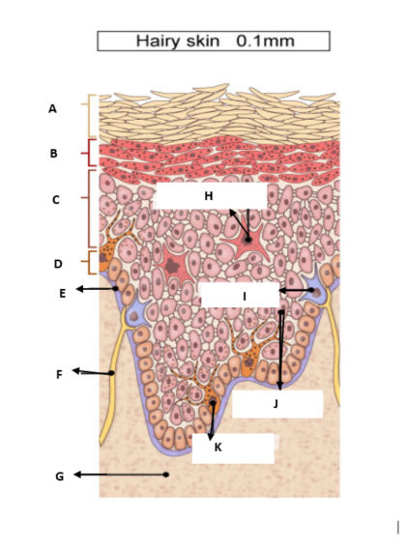

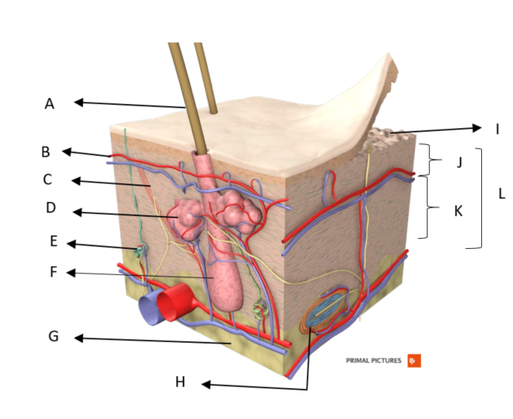
II. Gross anatomy of the skin. Complete the table using the image provided.

 | Structure | Function
A | Hair | Provides insulation and contributes to sensory perception.
B | Cutaneous blood vessel | It supplies oxygen and nutrients to the skin while regulating body temperature through vasodilation and vasoconstriction.
C | Arrector pili muscle | Contracts causing hair to stand and trap air, which insulates against heat loss
D | Sebaceous gland | Produces sebum, an oily substance that lubricates the skin and hair.
E | Merocrine sweat gland | Produces watery sweat to regulate body temperature and aid in waste excretion
F | Hair follicle | Anchors the hair into the skin and plays a role in the growth and regeneration of hair.
G | Hypodermis | Contains adipose tissue that insulates the body against heat loss.
H | Pacinian corpuscle | detects deep pressure and vibration
I | Dermal papilla | interlock with the epidermis thereby strengthening skin attachment
J | Papillary dermis | Nourishes the epidermis and contains blood vessels that participate in thermoregulation
K | Reticular dermis | Provides structural support and elasticity to the skin.
L | Dermis | It provides the skin with tensile strength and resistance to stretching, supplies the dermis with nutrients, and is involved in thermoregulation.

Part B: Thermoregulation
Use the diagram provided, to answer the questions.
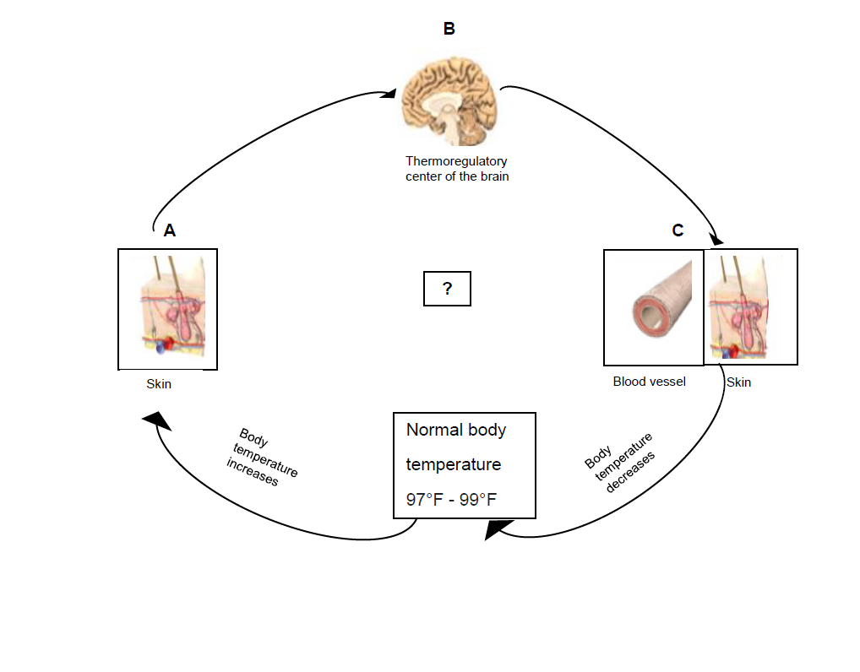

- Homeostatic regulatory mechanism involves atleast
3 independent components.Identify these components labeled as A, B, C in the diagram.
A. Receptor

B. Control center

C. Effector

2. Describe in your own words the physiological events that would occur during this feedback mechanism.
When the body experiences a deviation of temperature from the normal range, a negative feedback mechanism is initiated to restore temperature to normal and maintain homeostasis. The thermoreceptors in the skin detect changes in temperature and send signals to the control center, the hypothalamus. The hypothalamus sends signals to the effectors, such as the cutaneous blood vessels, and the temperature returns to normal. When the body is too hot, Vasodilation occurs, causing cutaneous blood vessels to widen, increasing blood flow to the skin’s surface, and allowing heat to escape. Sweat glands are stimulated to produce sweat, which evaporates and cools the body. When the body’s temperature reduces, the blood vessels will undergo vasoconstriction, the arrector pili muscle will contract, making the hair stand, and shivering can occur to generate heat.

3. Identify the condition that would occur due to increase in body temperature.
Hyperthermia

Part C: Skin Wound Healing- Anatomy TV
Instructions:
For this part of the lab you will use Anatomy TV to watch an animation on skin wound healing. Please read the instructions before you begin.
- Use the link below to log into Anatomy TV via Chamberlain Library.

https://library.chamberlain.edu/az.php?q=.
2. Select Anatomy TV under popular databases to access the site.
3. Select the ‘Integumentary System’ tile:


4. Select topics and click on Skin Wound Healing.

5. Watch the animation to answer the questions below:
- Compare and contrast the epidermal and dermal wound healing.
An epidermal wound does not penetrate the dermis, and healing is a simple process whereby basal epidermal cells multiply and migrate across the wound until it is covered.
A dermal wound penetrates the dermis and involves multiple tissue layers. The healing process is complex and involves three phases. It heals by scarring.

- Describe the first step in wound healing. What its significance?
The first step is hemostasis. A blood clot is formed to prevent further bleeding.

- Why is inflammation an important step in wound healing?
Inflammatory cells remove microbes and foreign particles via phagocytosis.

- What results in fibrosis during deep wound healing?
Fibroblasts infiltrate the wound and lay down collagen.

Part D: Case Studies:
Read the case study. In your own words and in complete sentences answer the questions.
Case Study 1
While preparing dinner Jane knocked a pan of boiling water onto herself. She suffered partial thickness burns to the anterior region of her legs.
- What is partial thickness burns?

Burns that involve both the dermis and the epidermis.

- Jane loose sensation of the affected area? Why?
Jane felt pain because second-degree or partial-thickness burns extend into the dermis where nerve endings are still intact.

- Using the Rule of Nines calculate the total body surface area percentage that is burned?
The anterior region of each leg is 9% of the total body surface area (4.5% per thigh and 4.5% per lower leg). Since Jane burned both legs, the total TBSA affected is 18%.

Case Study 2
Tom, a 14-year-old teenager, fell into the partially frozen pond during his walk with his friends. His friends rescued him and took him back to the car. On the walk back, Tom, started to show signs of hypothermia.
- What is hypothermia?
It is a condition that occurs when the core body temperature drops below 95°F or 35°C

- Which skin receptors detect a decrease in temperature?
Krause end bulbs and cold receptors on free nerve ending.

- Which control center monitors the signaling from these skin receptors?
The hypothalamus

- What happens to the blood vessels in the skin during hypothermia? What is the purpose of this response?
The blood vessels undergo vasoconstriction to reduce blood flow to the skin and prevent heat loss.

- What will happen to the hairs in Tom’s skin? What is the purpose of this response?
The hairs will stand erect due to the contraction of the arrector pili muscle. This traps a layer of air that insulates against heat loss.

- What would be the feedback mechanism involved to bring back Tom’s temperature back to normal?
Negative feedback mechanism

Grading Rubric:
Activity | Deliverable | Points
Part A (I & II) | Skin Structure and Functions | 10
Part B, C & D | Answer all the questions  - Part B - Thermoregulation  - Part C – Skin Wound Healing  - Part D –Case studies | 5  5  10
Total | Complete all lab activities | 30

